

| Business Template  **Introduction to DWBI Systems Testing** |
| --- |
|  |

**Notice:** <https://dqteamcuknurilta.testrail.io/index.php?/projects/overview/40>

(link to my project in Test Rail)

# Test cases creation

1. In TestRail create your own project Name Surname

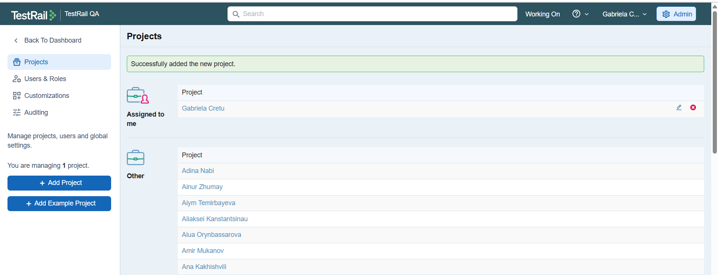

2. In your project as part of Test Cases tab create three Sections wirh propper description for test cases divided by:

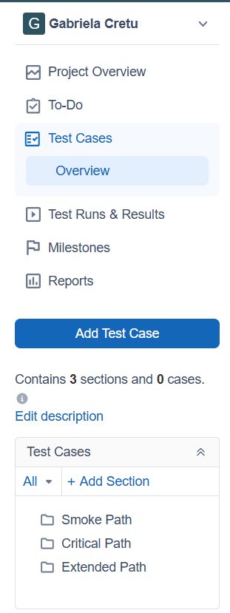

a. Smoke path

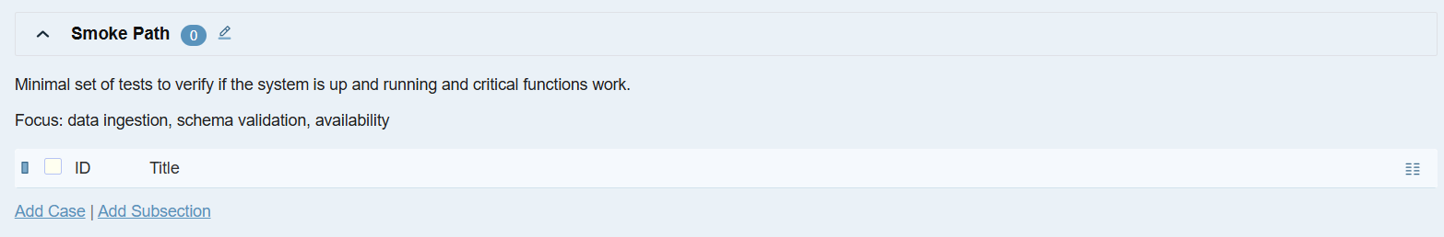

b. Critical path

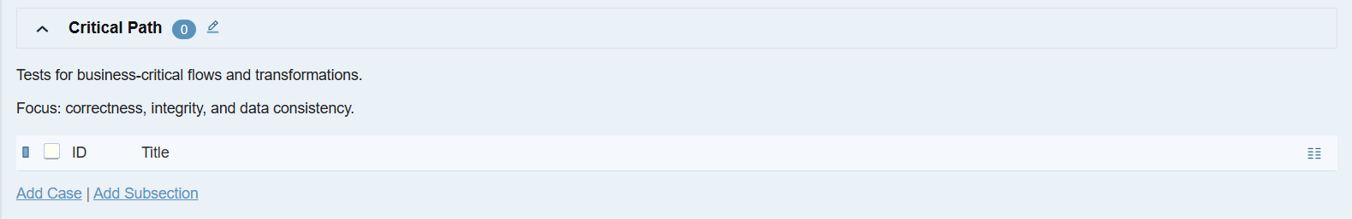

c. Extended path

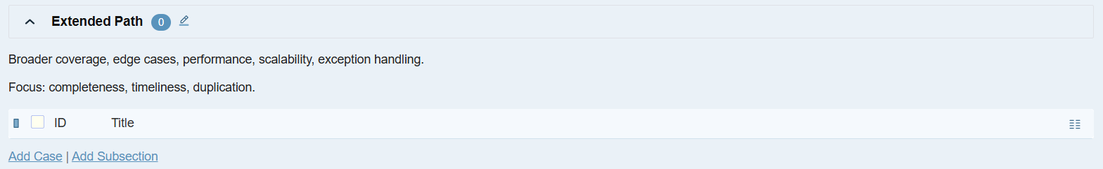

3. Explore provided schema for the data platform.

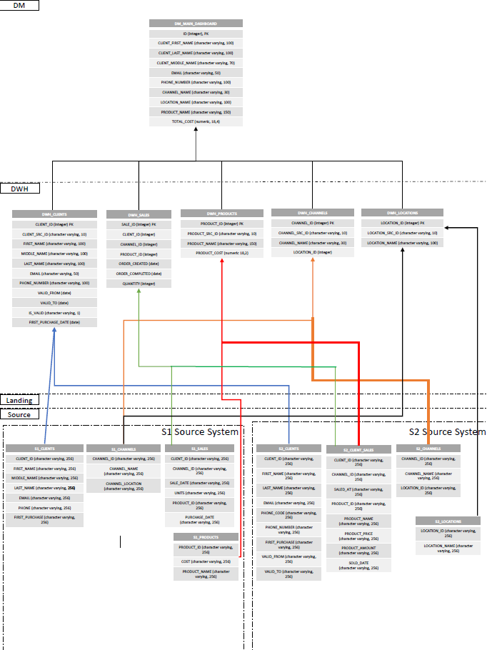

4. Create test cases to verify the data platform and cover corresponding Data Quality areas, which correspond to the test levels (smoke/critical path/extended)

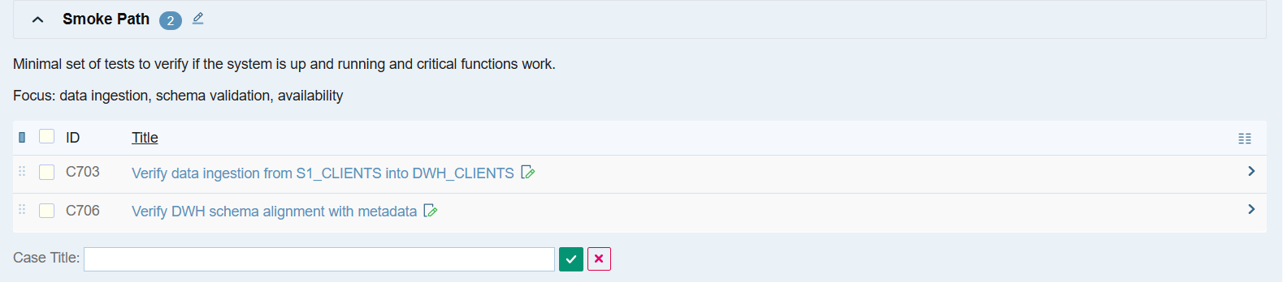

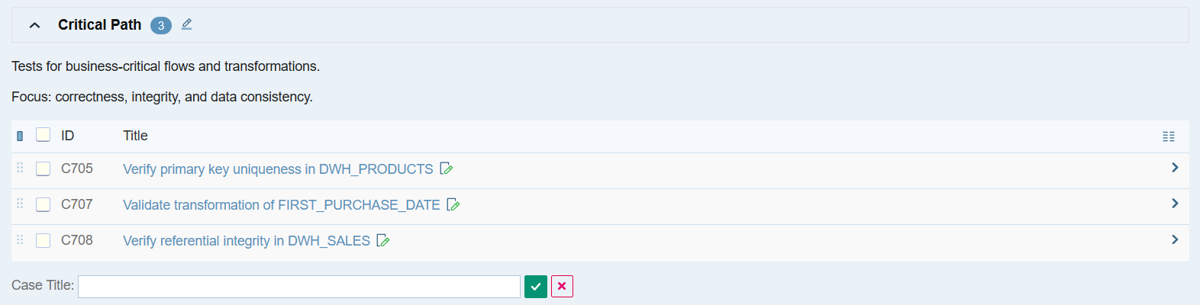

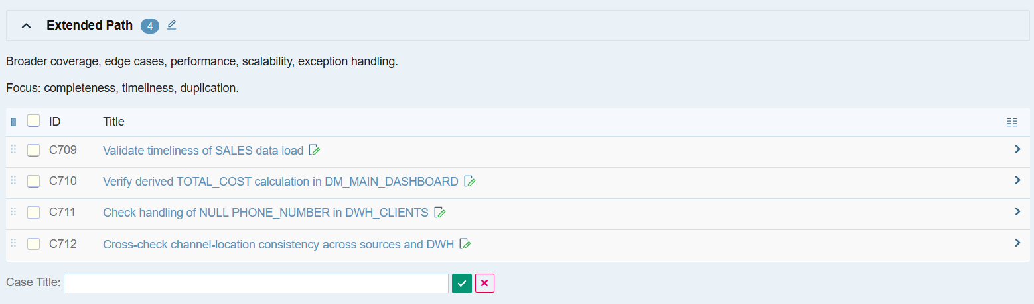

5. For each test case set appropriate Data Quality dimension . In case if Test Case related to 2 DQ dimension you could set 2 in the Test Case, but this situation should be reduced to a minimum.Smoke Path

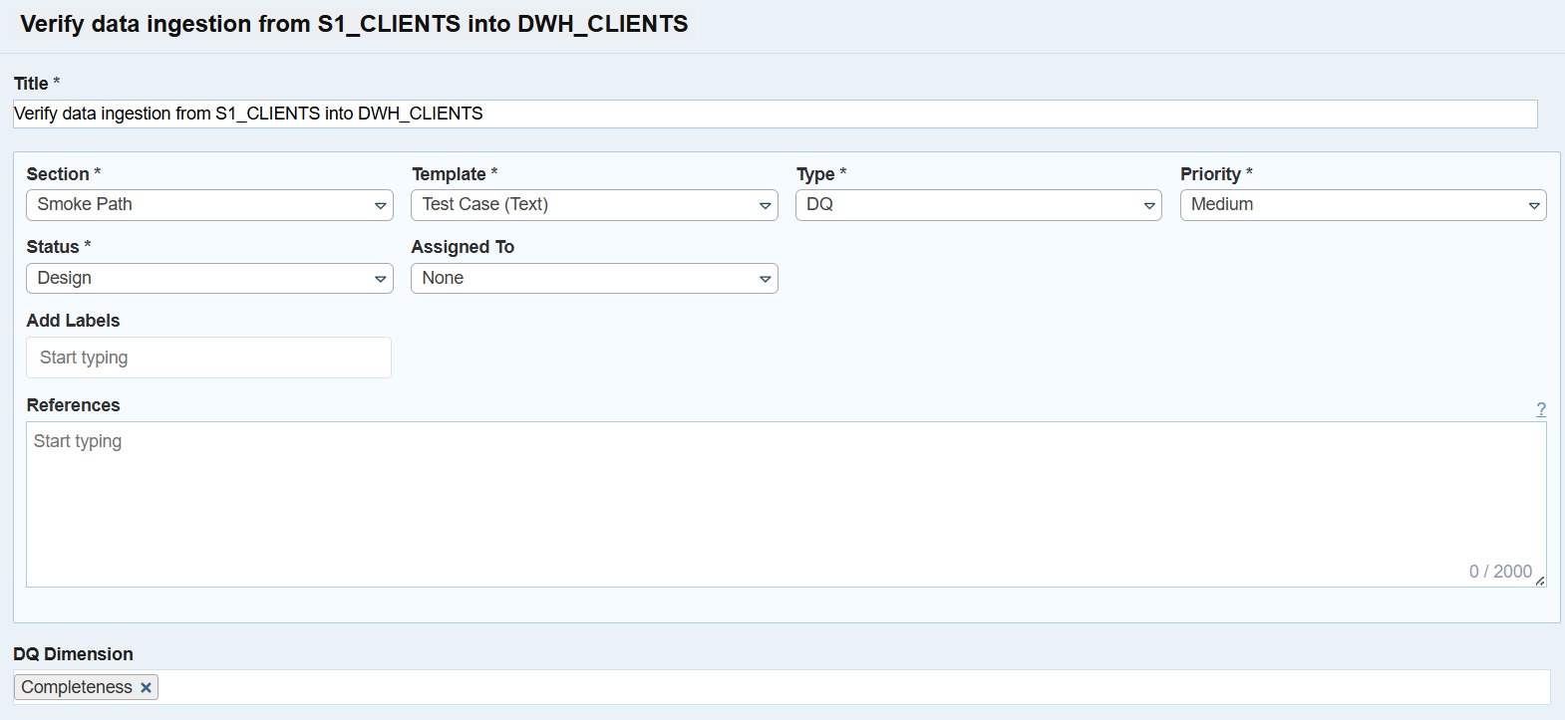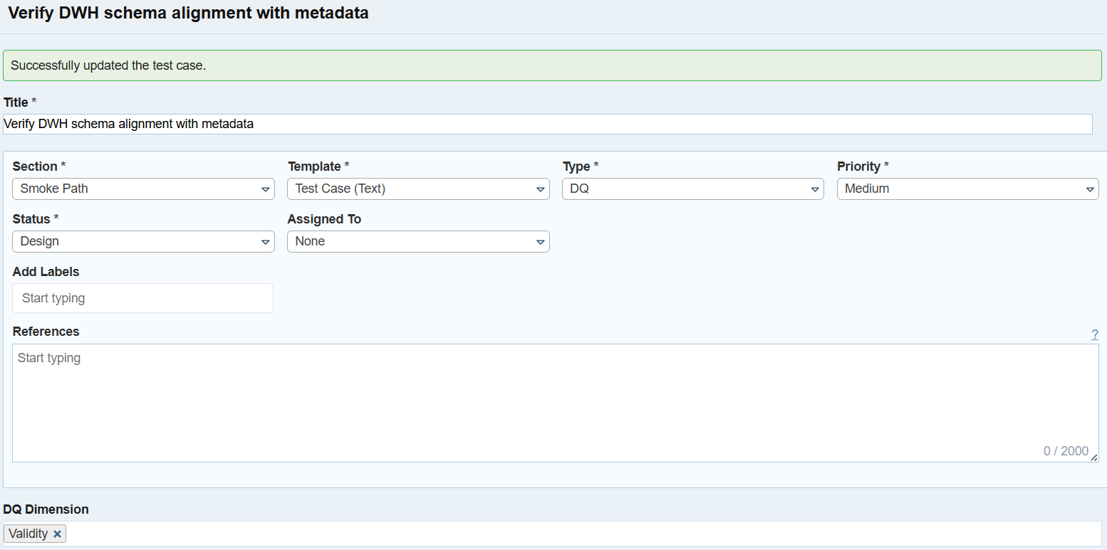

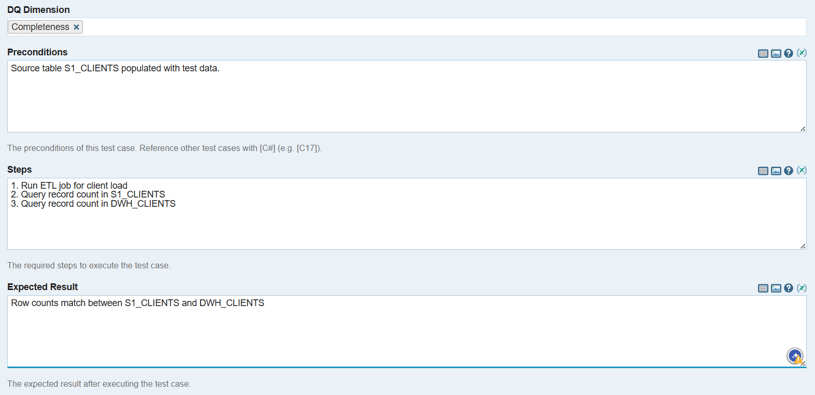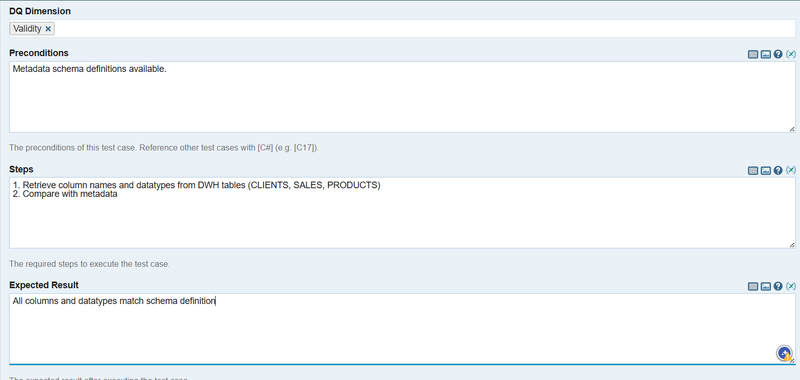

Critical Path

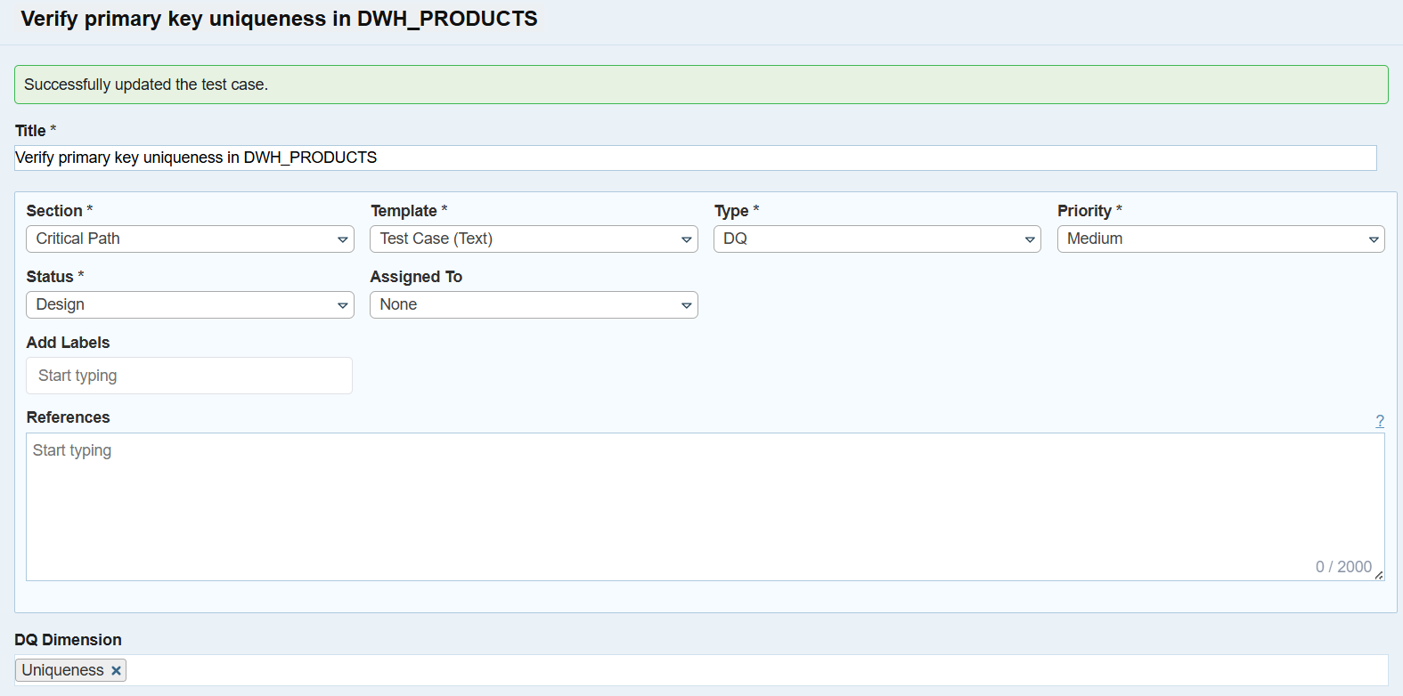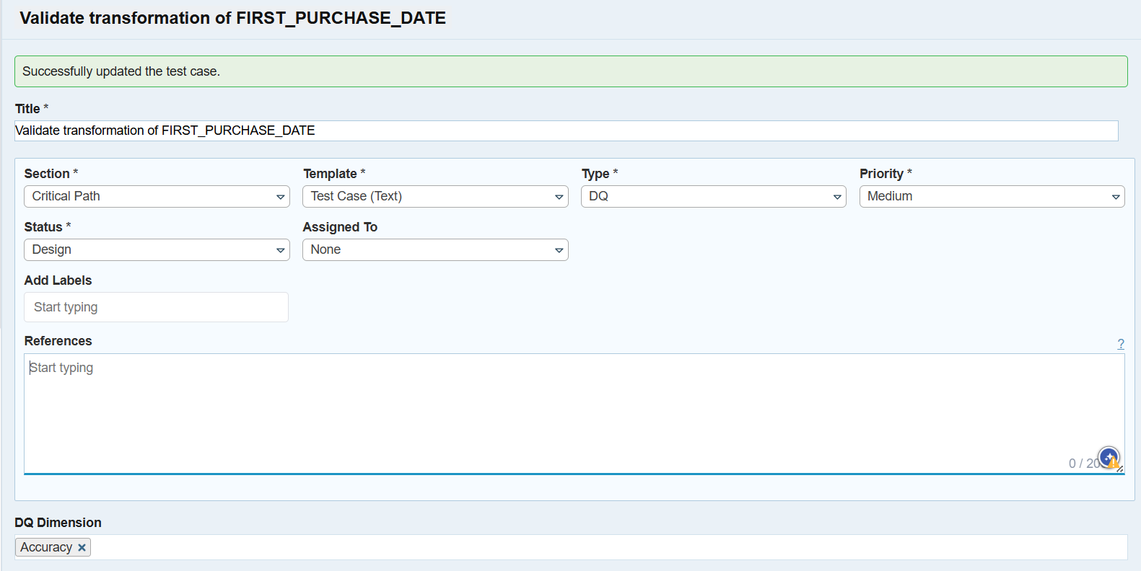

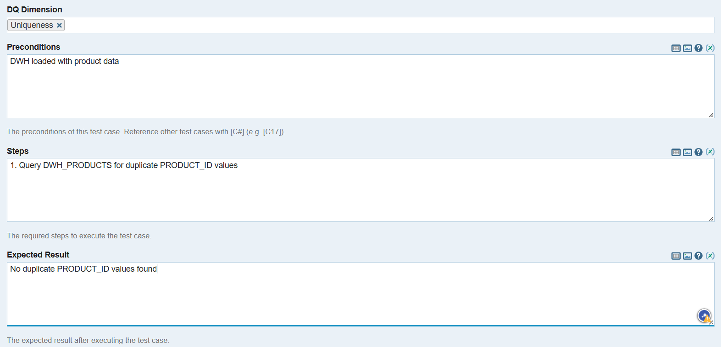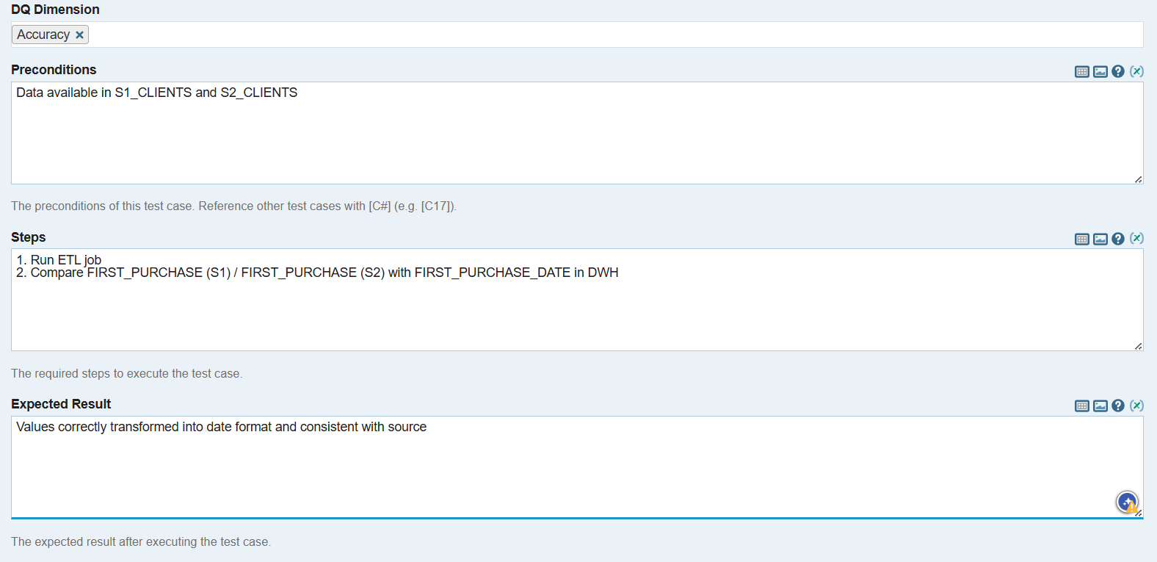

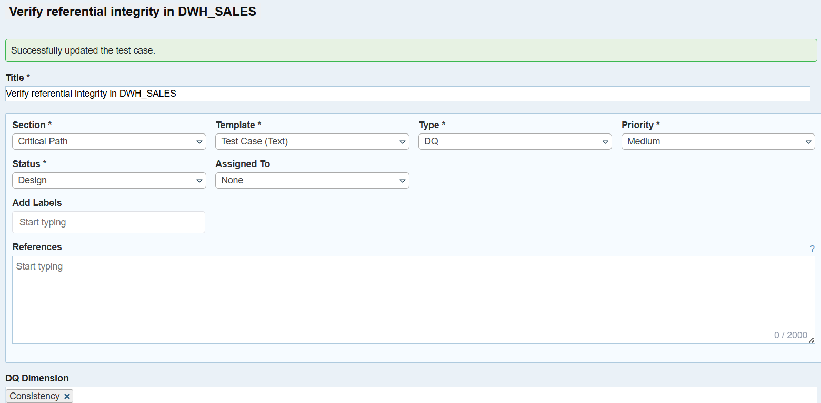

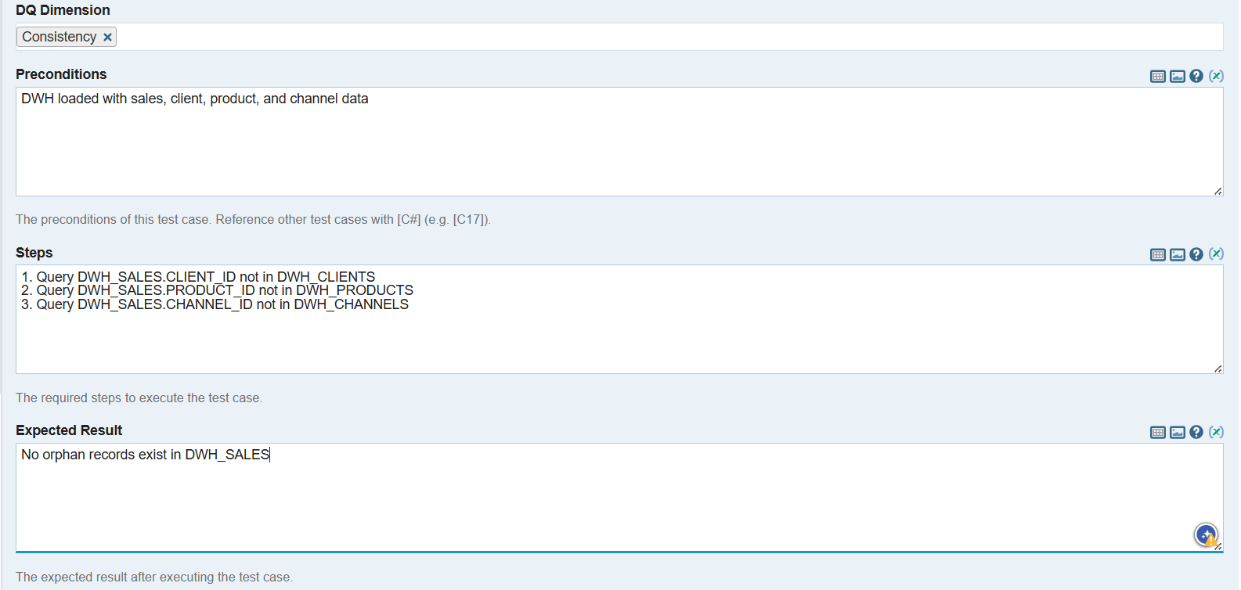

Extended Path

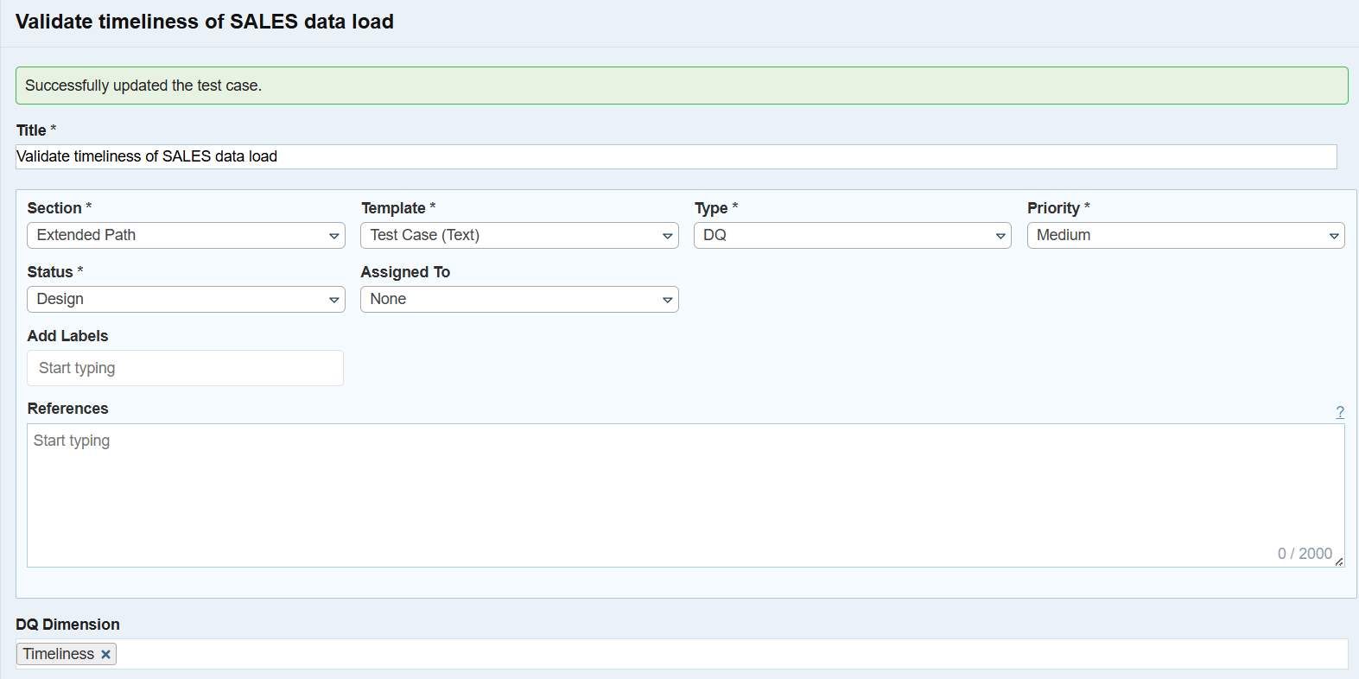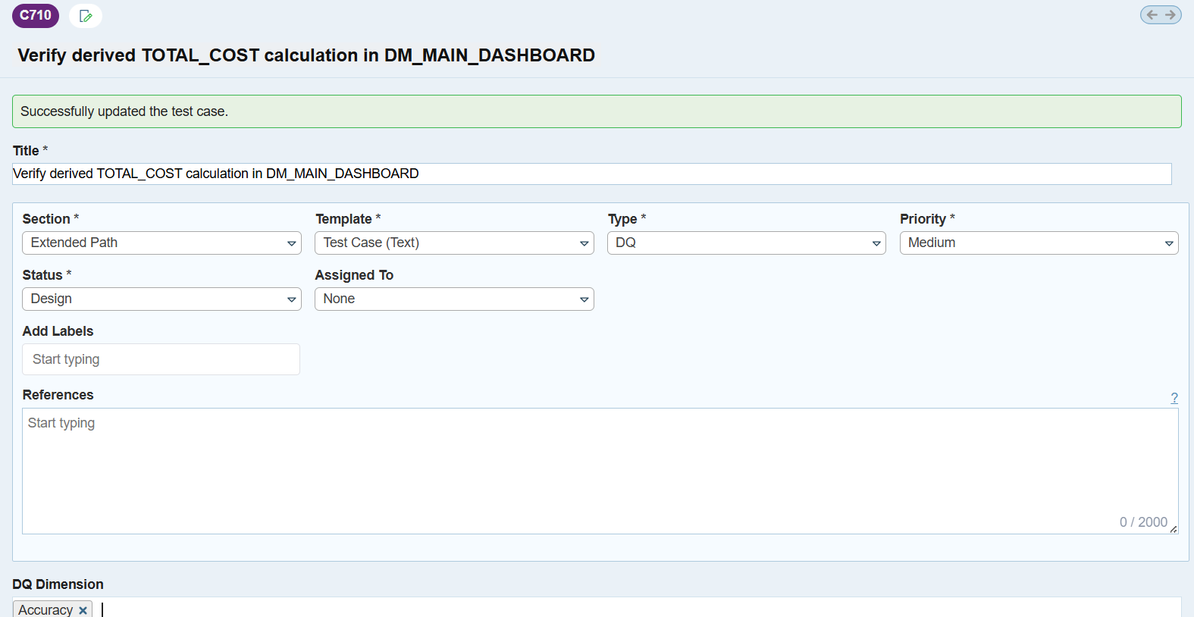

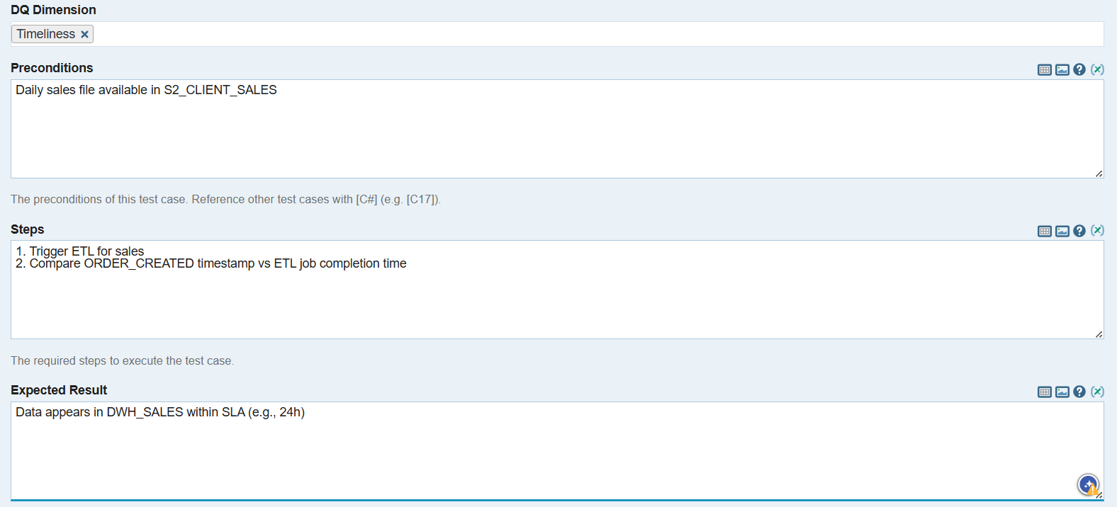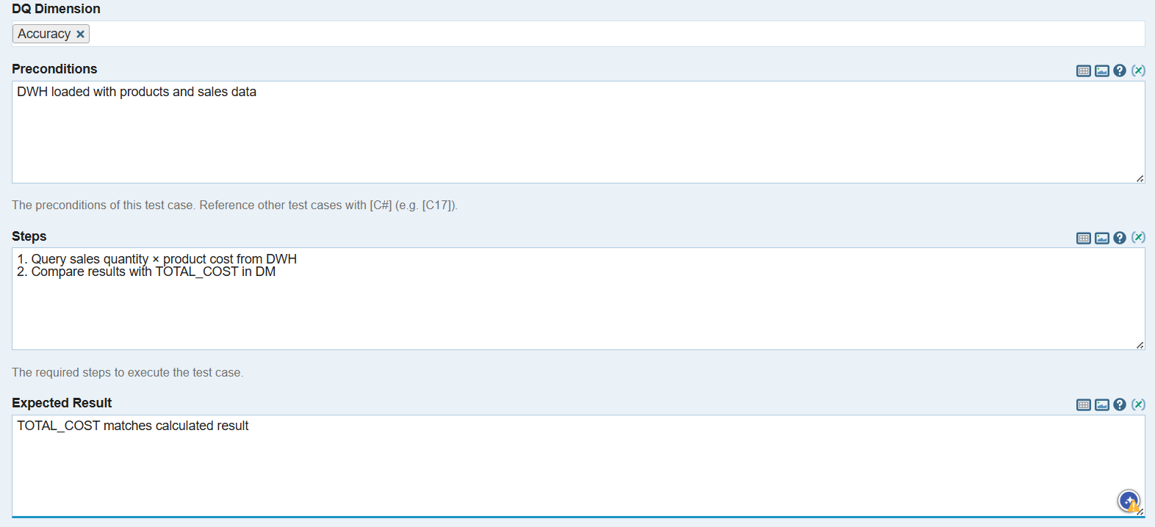

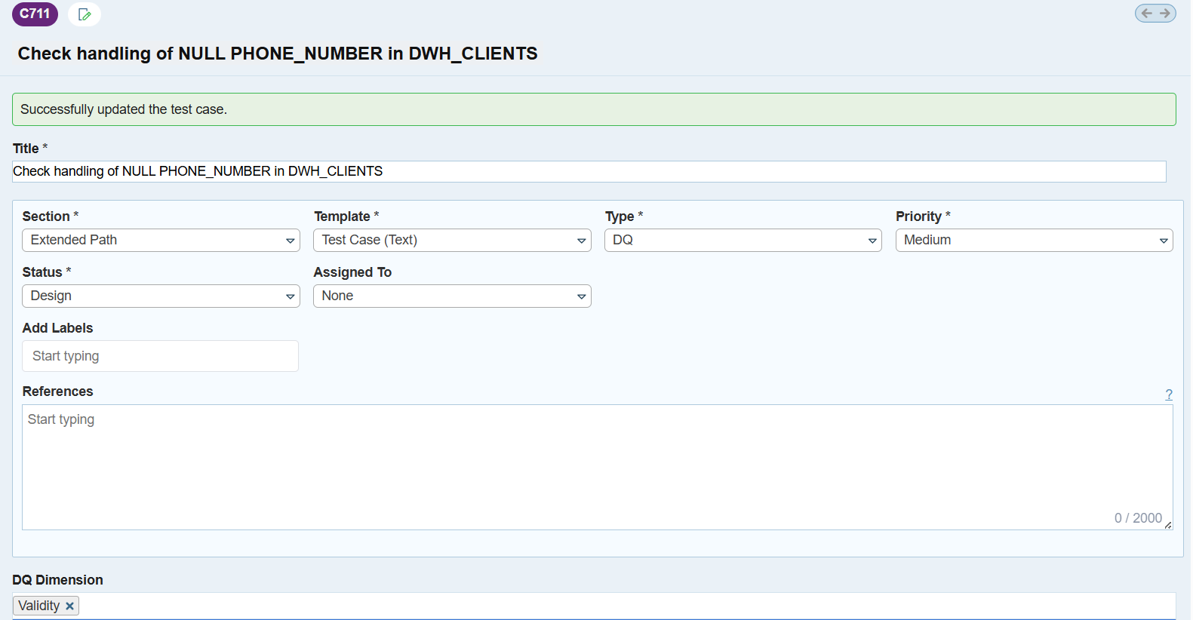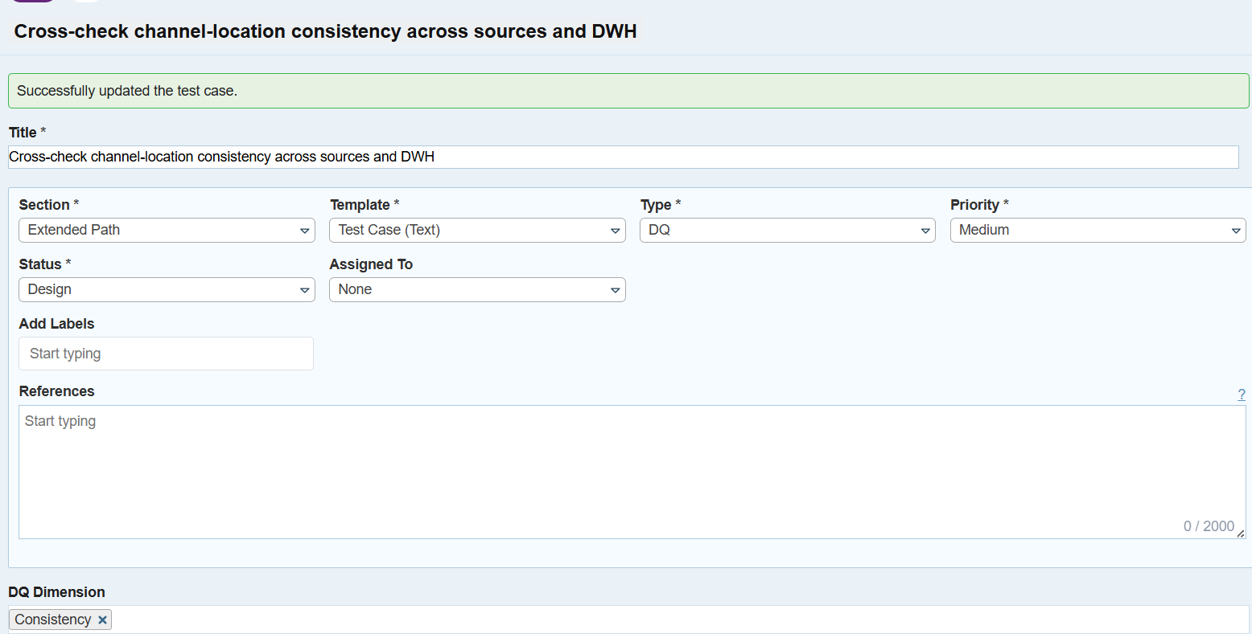

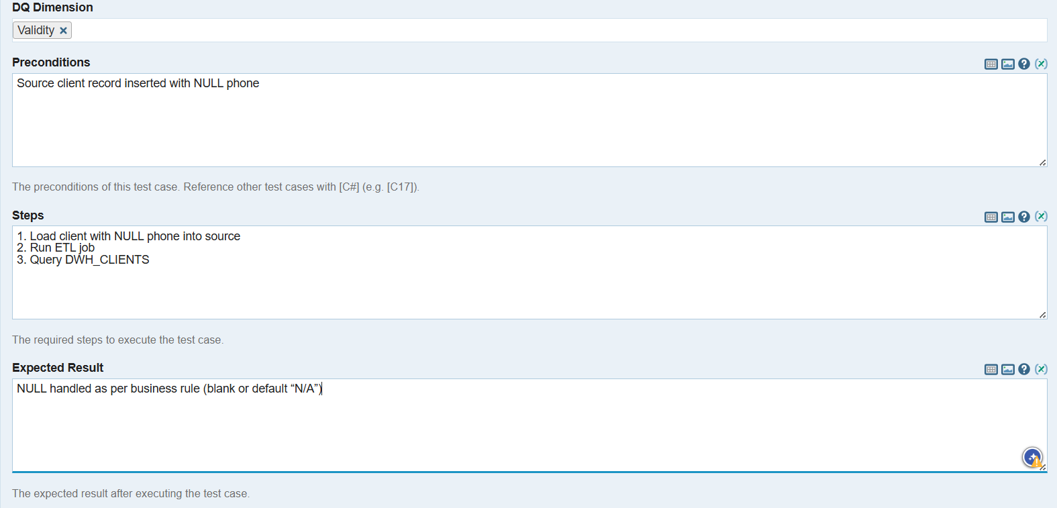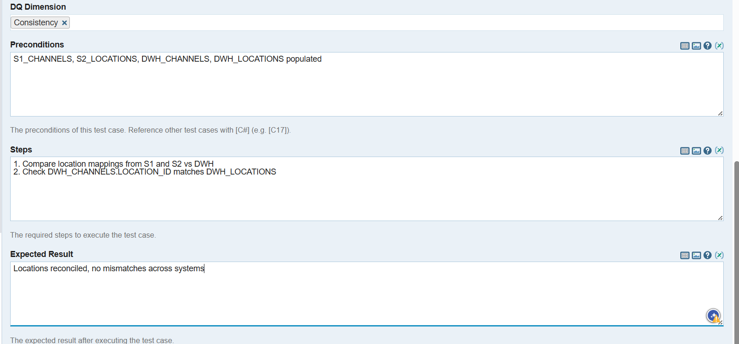

6. Your next step is to create a test suite, which is a collection of test cases grouped together based on a specific feature, module, or testing objective. Navigate to the Test Runs & Results tab, then Add a Test Run specifically for Unit Tests (include only test cases that are relevant for that) and assign it to yourself

